
INTERNET Resources & SMART Boards

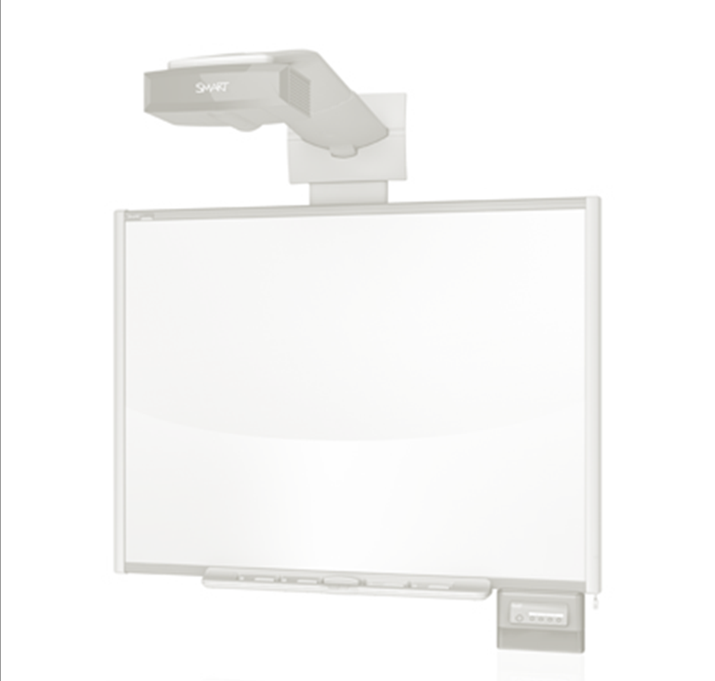
Math:
Math Doodles
Measurements
Equivalents
Coordinates
Decimals

Social Studies
Ancient Egypt
US State Geography
Learn English Kids

English
Spin & Spell
Spelling Bees
Wall of Words

Science
The Skeleton
Moon Phase
The Digestive System

Other Resources
Saleria Blue Delicious Page
Heather Lamb Delicious Page
Harvey Almarode

